This document assumes you have access to the Oracle MyLearn Activity Guide. We do not reproduce its content here, but rather explain how to configure the environment with Payara 5 instead of WebLogic so you can follow along.

For this guide you will need:
NetBeans 29
Java 11
Apache Derby 10.15.2.0 (configured in NetBeans)

Lesson 2:
2-1
1. Window > Services to open Services tab.
2. Right Click Servers → Add Server
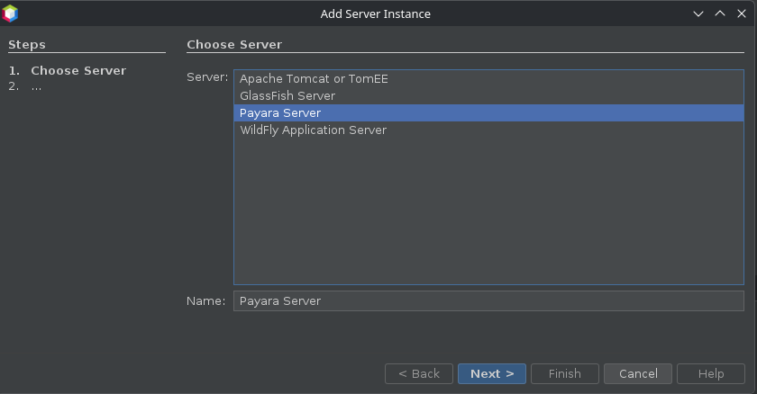

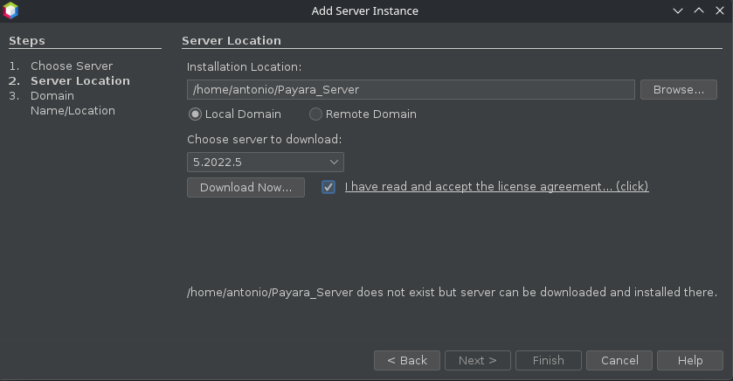

3. Download Now… → Next
4. Only change:
User name: payara
Password: welcome1
5. Finish
6. Right click Payara Server → Start
7. Leave this empty when it pops
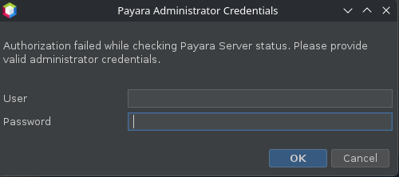

8. Right click Payara Server → View Domain Admin Console

